<https://nordicapis.com/5-examples-of-apis-we-use-in-our-everyday-lives/>

API : Application Programming Interface

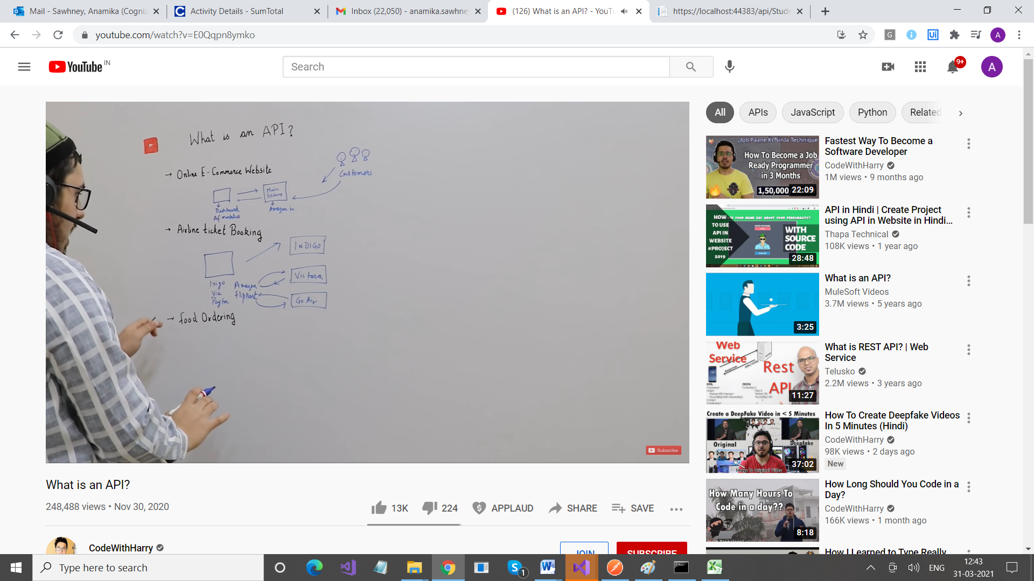

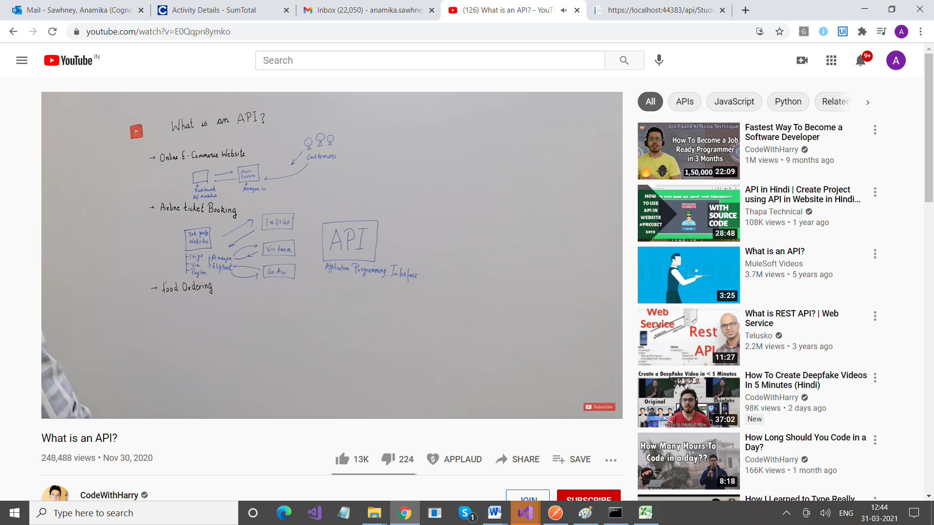

If you want to expose the data/information of your application to your clients and other people then that other people can use your data and interact with the data/information you expose to them.

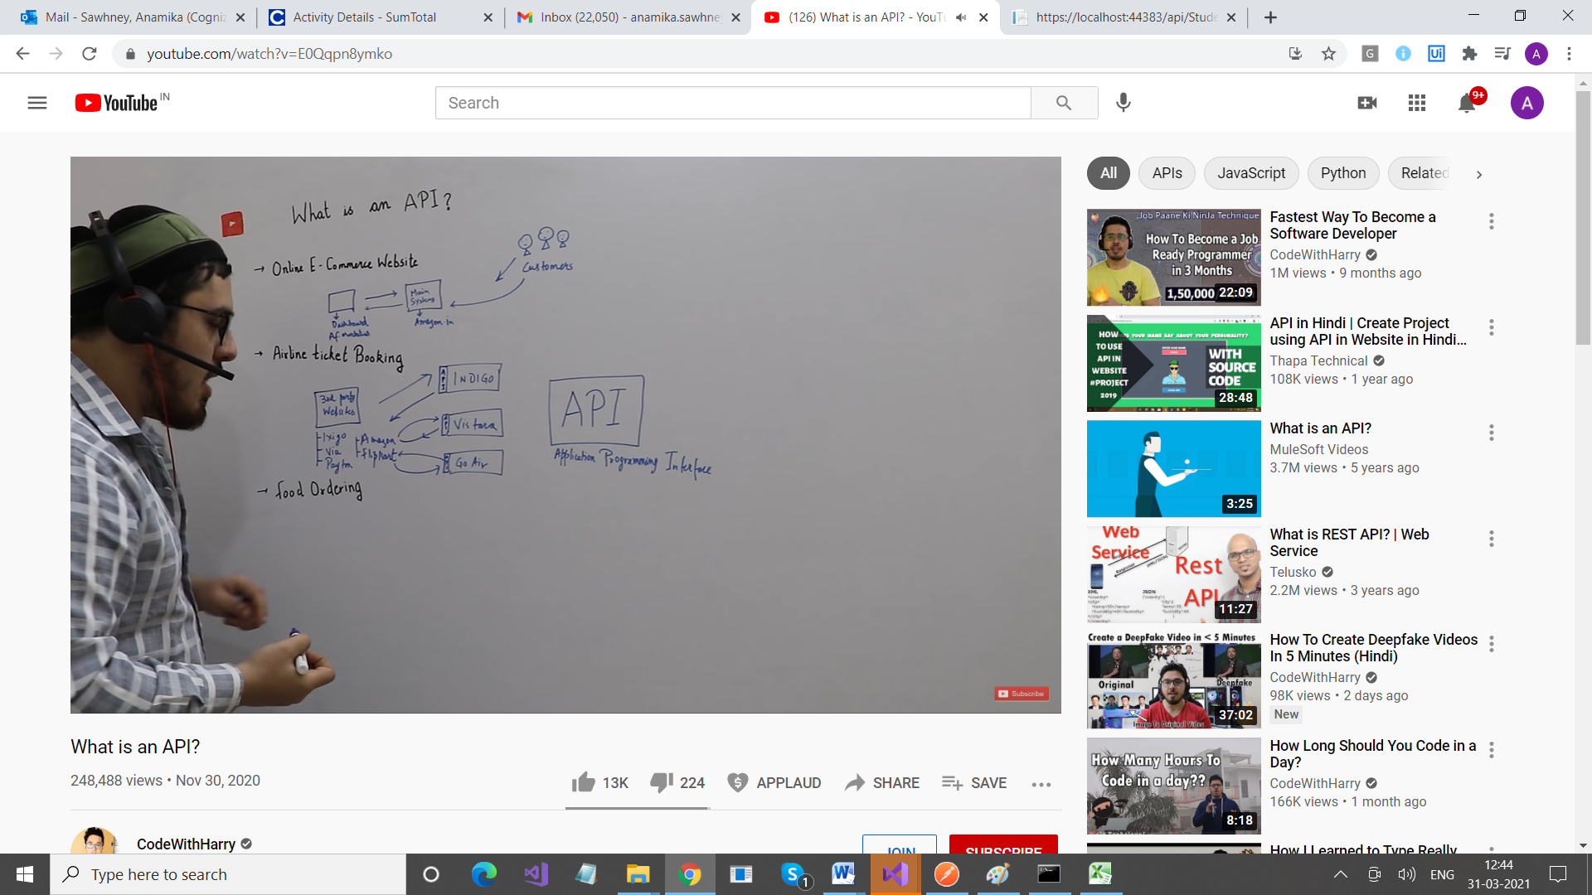



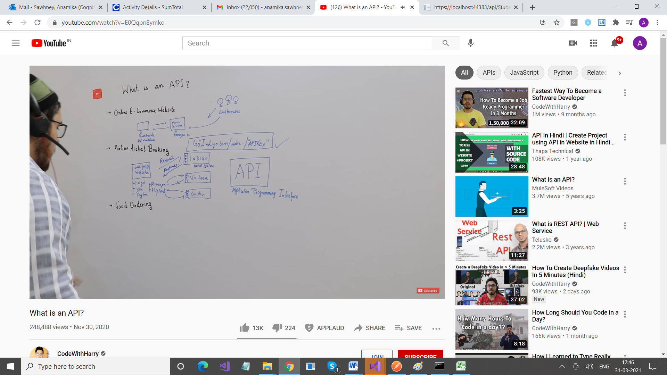

API makes it possible for different systems to interact with each other

API helps all these systems (INDIGO, etc) to expose their data.

So Indigo and Amazon will interact via sAPI

Example of Customer & Waiter & Chef

Here Waiter is API